ASSIGNMENT – 7.3
Task Description#1
• Paste a function with a missing colon (add(a, b)), and let AI fix the syntax error.
Expected Output#1
• Corrected function with syntax fix
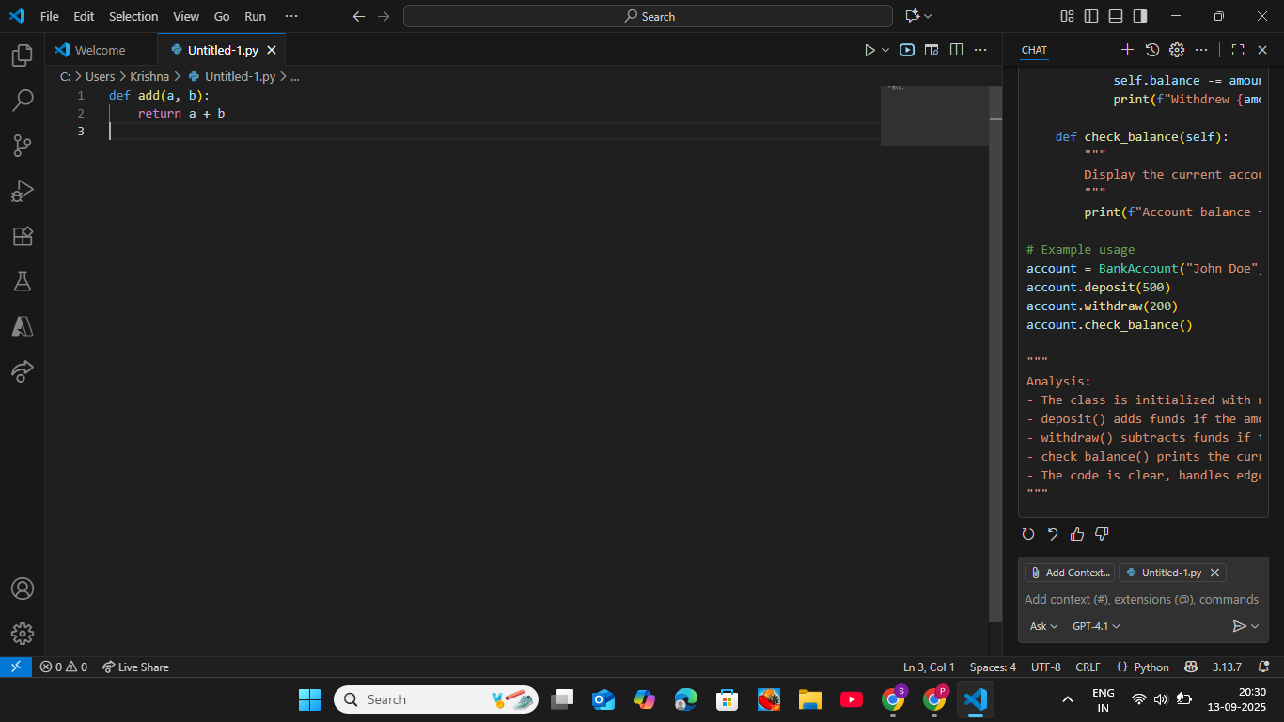

Task Description#2 (Loops)
• Identify and fix a logic error in a loop that causes infinite iteration.
Expected Output#2
• AI fixes increment/decrement error.

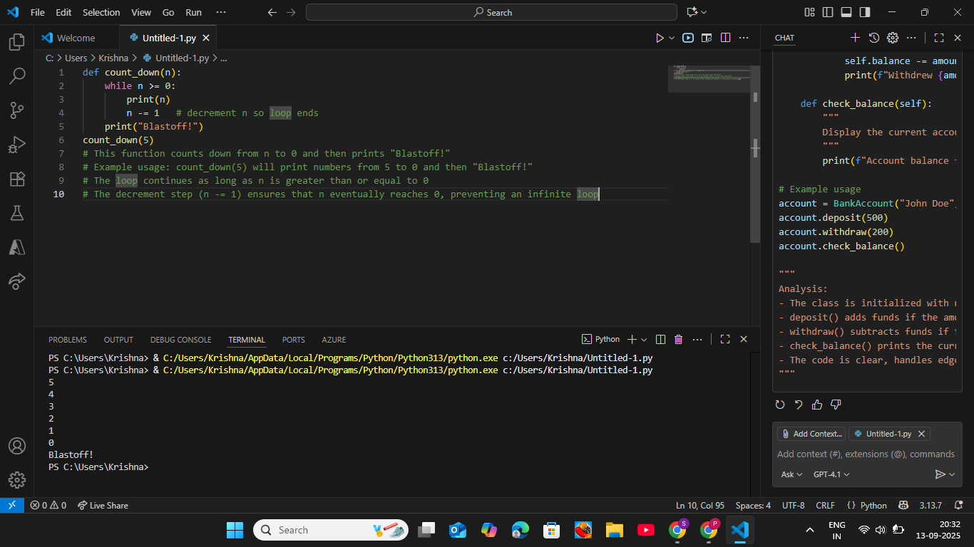

Task Description#3
• Debug a runtime error caused by division by zero. Let AI insert try-except.
Expected Output#3
• Corrected function with safe error handling.
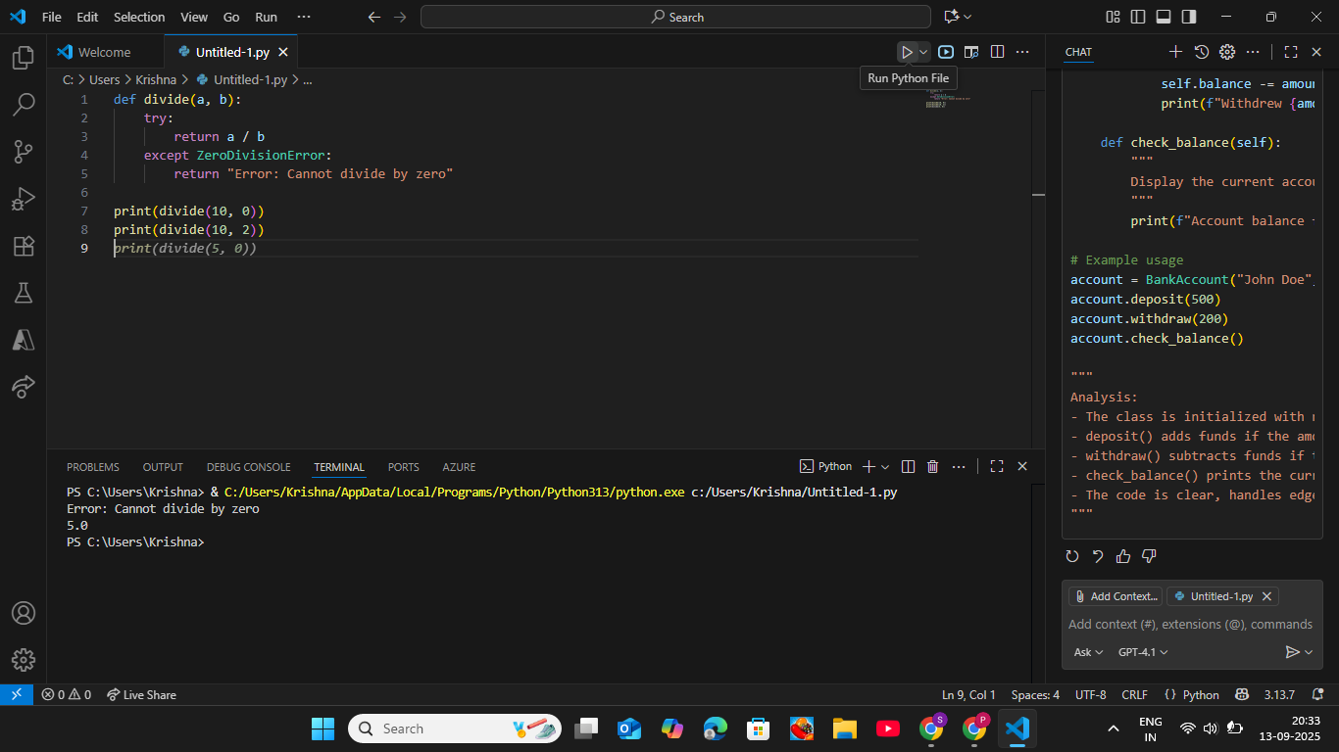

Task Description#4
• Provide a faulty class definition (missing self in parameters). Let AI fix it
Expected Output#4
• Correct __init__() method and explanation.

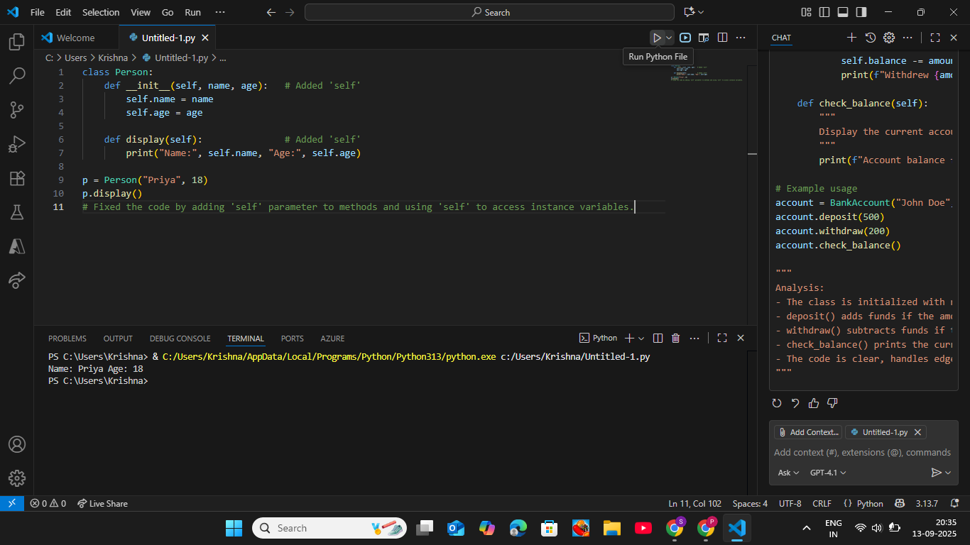

Task Description#5
• Access an invalid list index and use AI to resolve the Index Error.
Expected Output#5
• AI suggests checking length or using safe access logic.